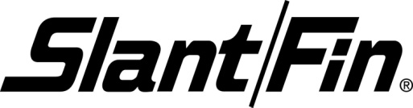
FACTORY WAREHOUSE OPEN HOUSE !
COME CHECK OUT OUR NEWEST BOILERS, RESIDENTIAL & COMMERCIAL BASEBOARD.
MEET KEITH MUHLMEISTER FROM OUR NY FACTORY
FOOD & REFRESHMENTS WILL BE SERVED!

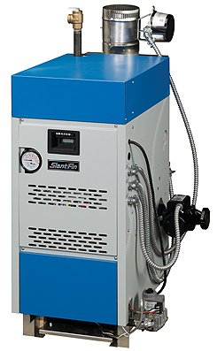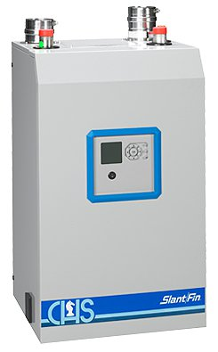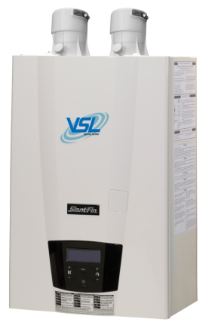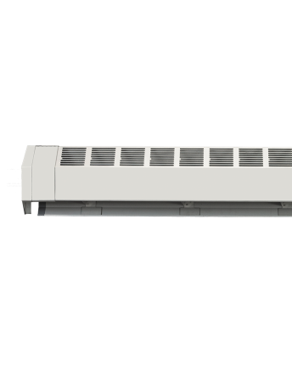

WHEN: THURSDAY, SEPTEMBER 22ND, 2016
4PM – 7PM
WHERE: SLANT/FIN DENVER
4770 FOREST ST. UNIT # B
DENVER, CO. 80216 / 303-399-2208
PRIZES & GIVEAWAYS TOO !

